CO1-AT1
Name: K.Varshini
Reg no:192472358
Course code: MLA0304
Course name: Reinforcement Learning

Experiment 1: Installation of Reinforcement Learning Development
Environment
Aim: To install and configure Anaconda Navigator, Python, TensorFlow, Keras,
Gymnasium (OpenAI Gym), NumPy, Matplotlib, and other required libraries, and
verify the environment by executing a simple Reinforcement Learning program.
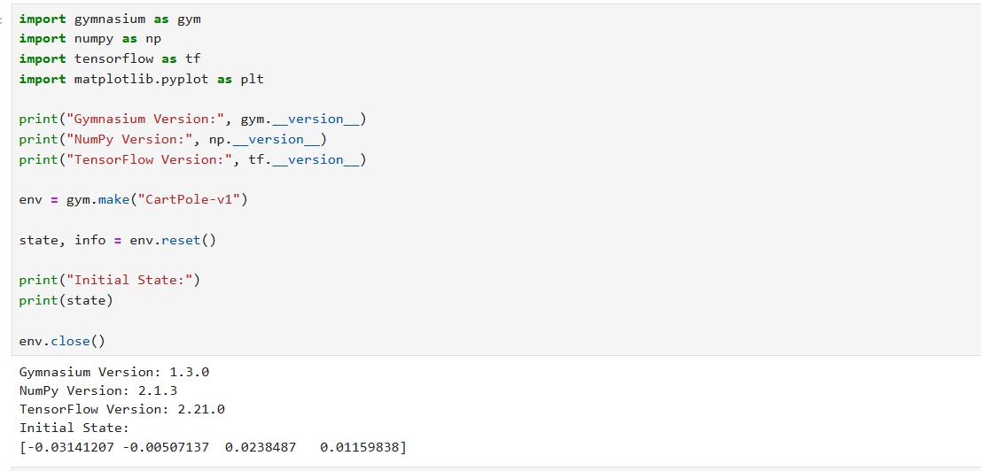
Experiment 2: Familiarization with OpenAI Gym/Gymnasium Environments
Aim: To create, initialize, and interact with standard Reinforcement Learning
environments such as FrozenLake, CartPole, and MountainCar using Gymnasium to
understand the concepts of states, actions, rewards, and episodes.
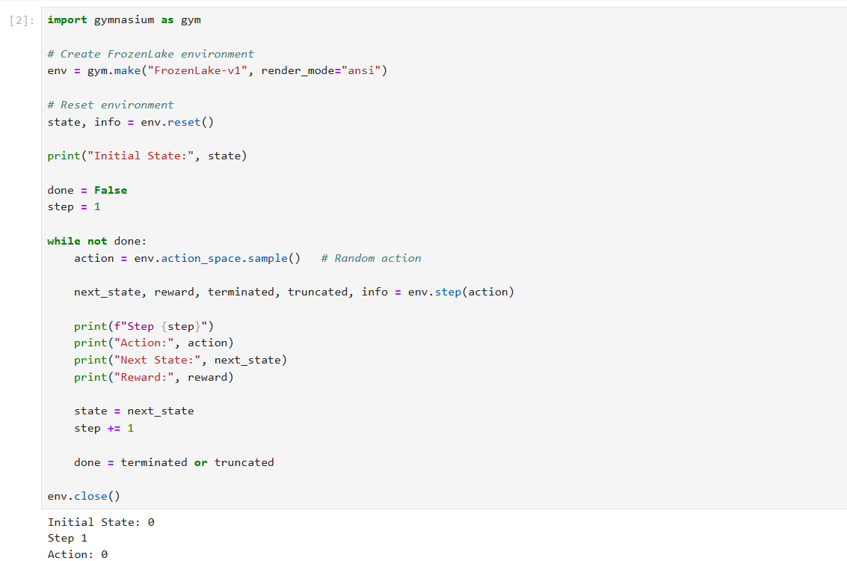
Experiment 3: Implementation of the Reinforcement Learning Framework
Aim: To implement the basic Reinforcement Learning framework by designing an
agent that interacts with an environment through states, actions, rewards, and
policies using Python.
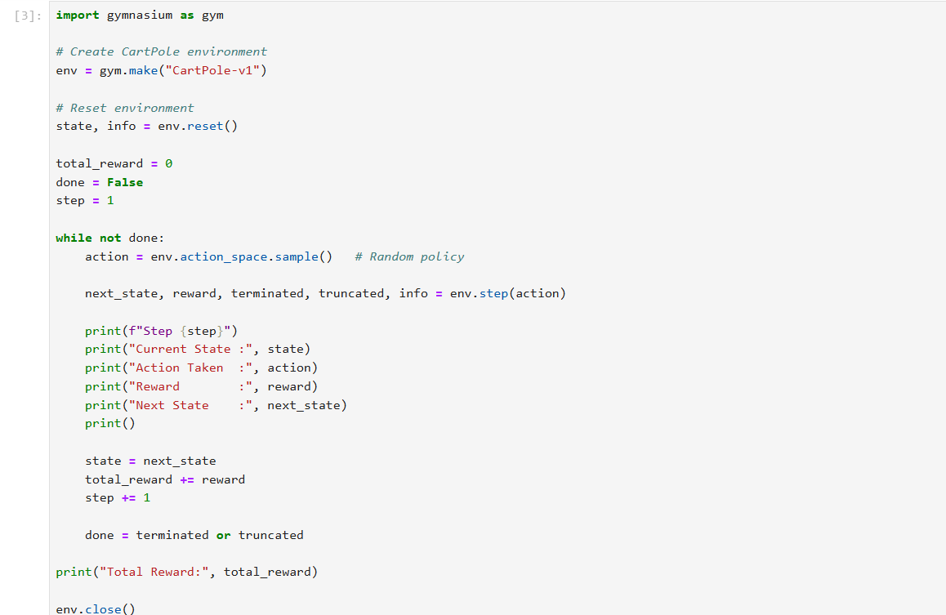
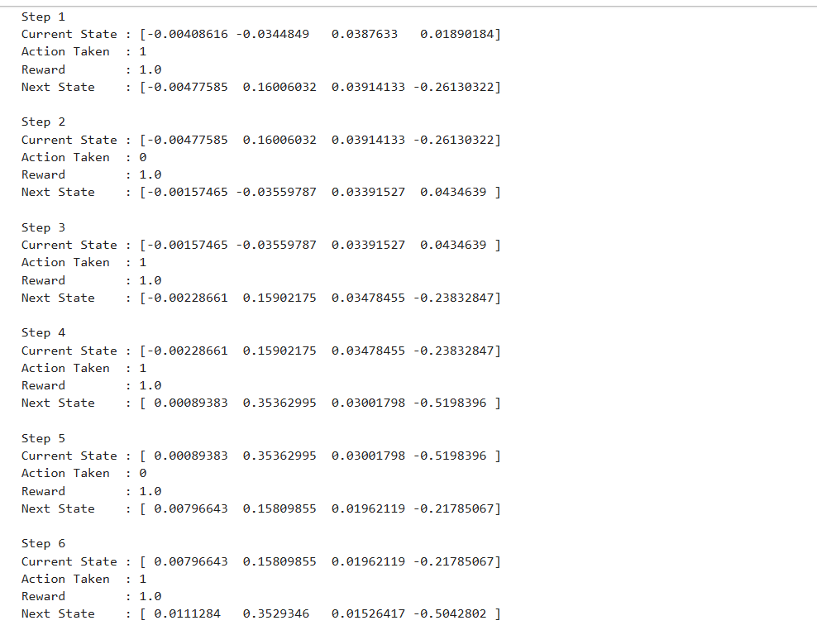
Experiment 4: Simulation of a Markov Decision Process (MDP)
Aim: To develop a simple Markov Decision Process model and simulate state
transitions, reward functions, and policy execution for understanding sequential
decision-making problems.
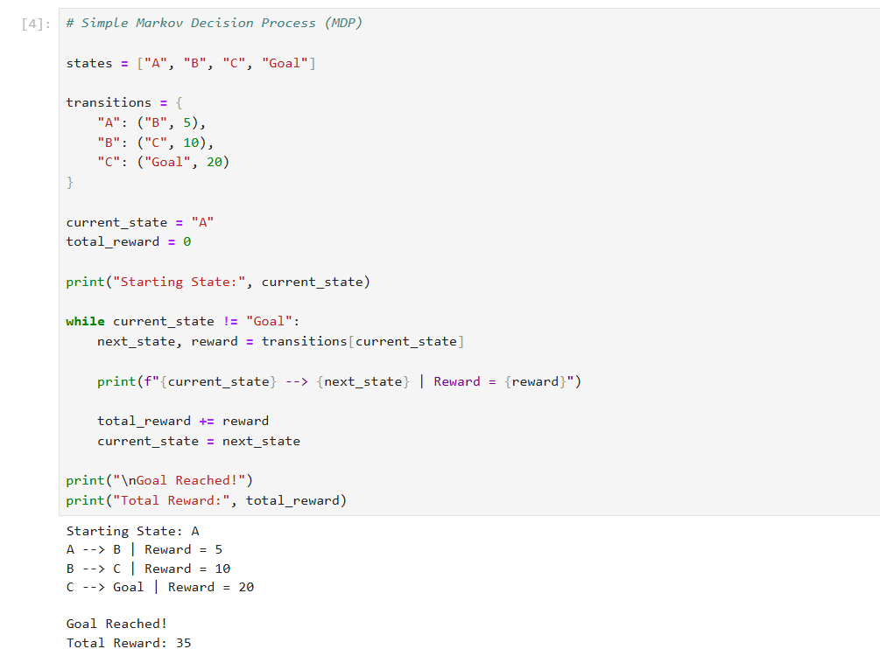
Experiment 5: Bellman Equation Demonstration
Aim: To implement Bellman Expectation and Bellman Optimality Equations for
calculating state-value and action-value functions and analyze the convergence of
value estimation.
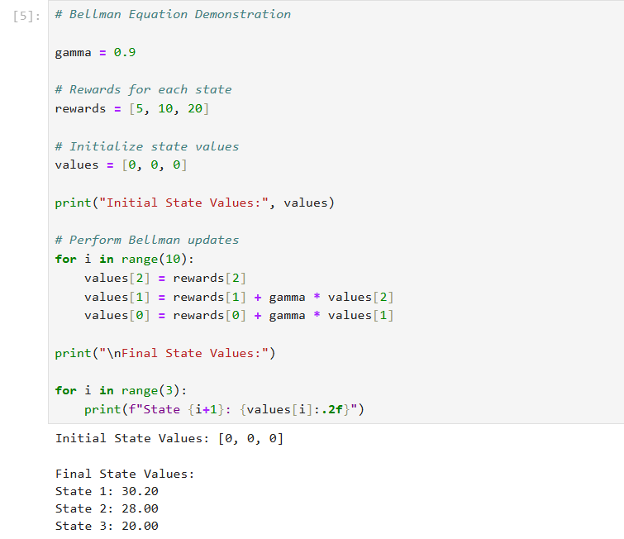
Experiment 6: Exploration vs. Exploitation Strategies
Aim: To implement ε-Greedy, Greedy, and Random action-selection strategies and
compare their performance in balancing exploration and exploitation during
Reinforcement Learning.

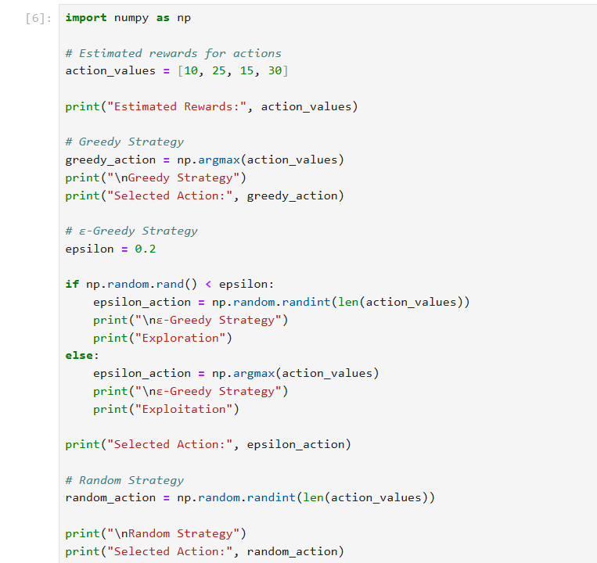
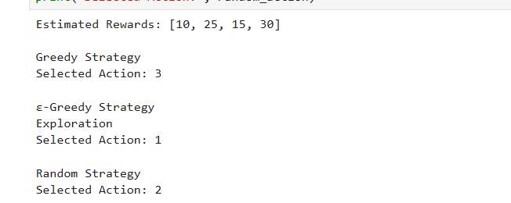
Experiment 7: Multi-Armed Bandit Problem
Aim: To implement the Multi-Armed Bandit problem using ε-Greedy and Upper
Confidence Bound (UCB) algorithms and evaluate cumulative rewards obtained by
different action-selection methods.
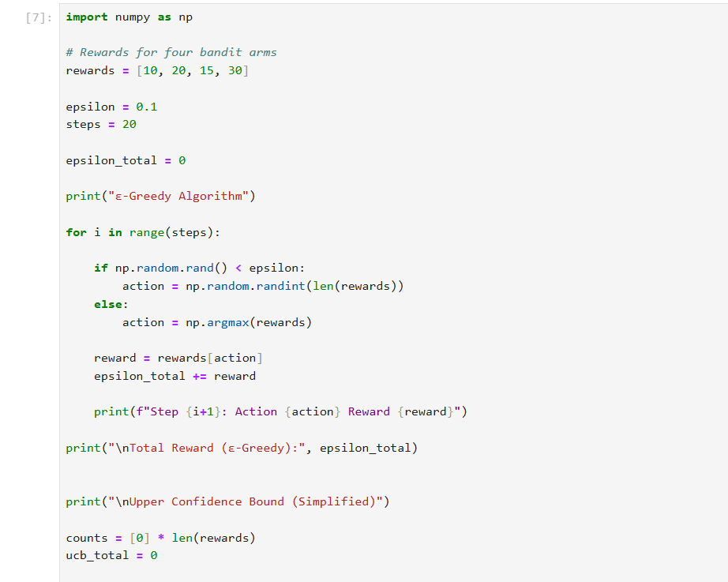
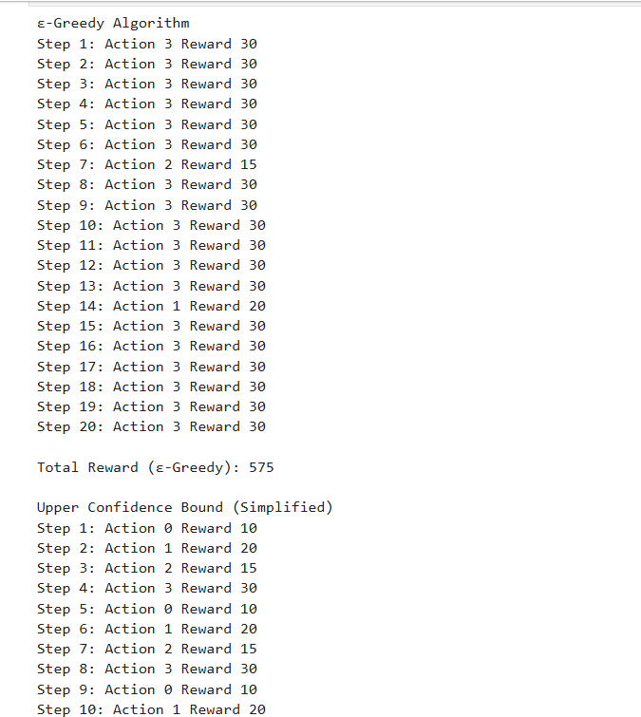
Experiment 8: Reward Visualization in Reinforcement Learning
Aim: To simulate an RL agent in a simple environment and visualize cumulative
rewards, episode rewards, and learning performance using Matplotlib graphs.
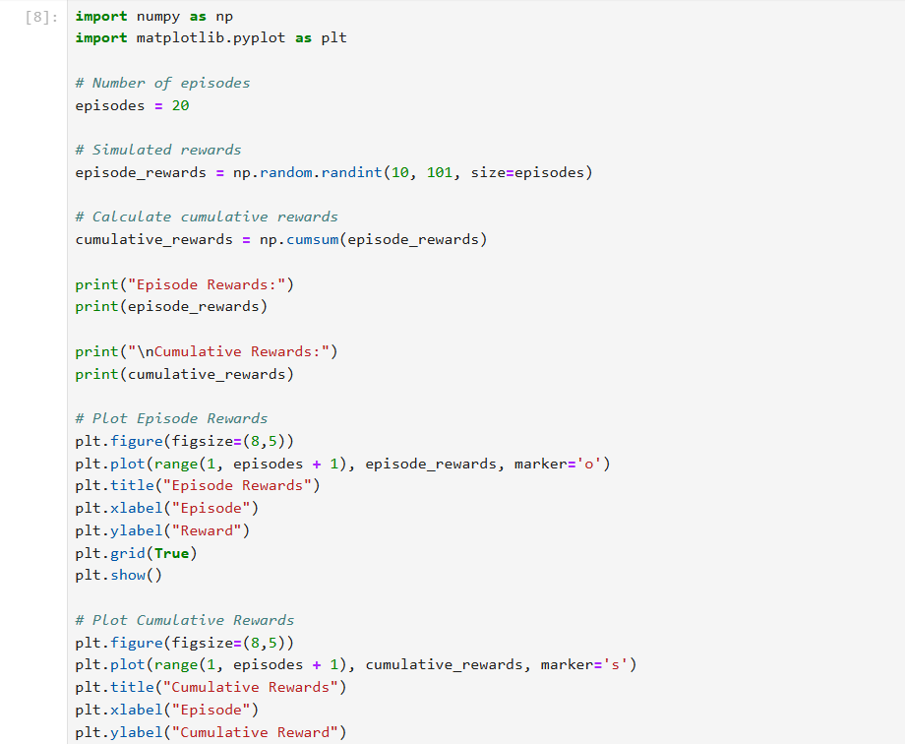
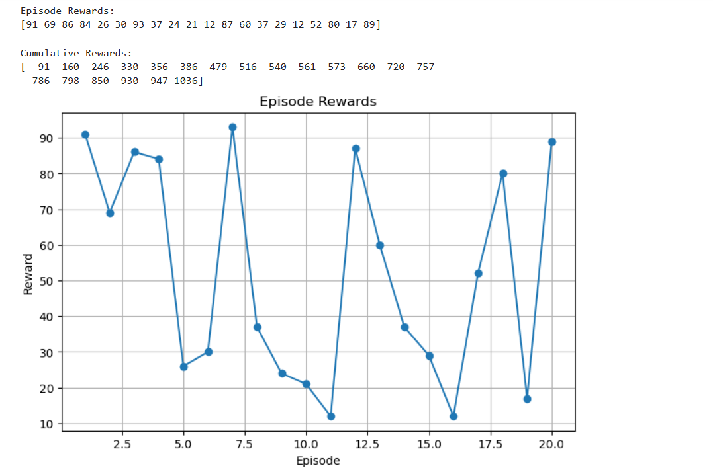
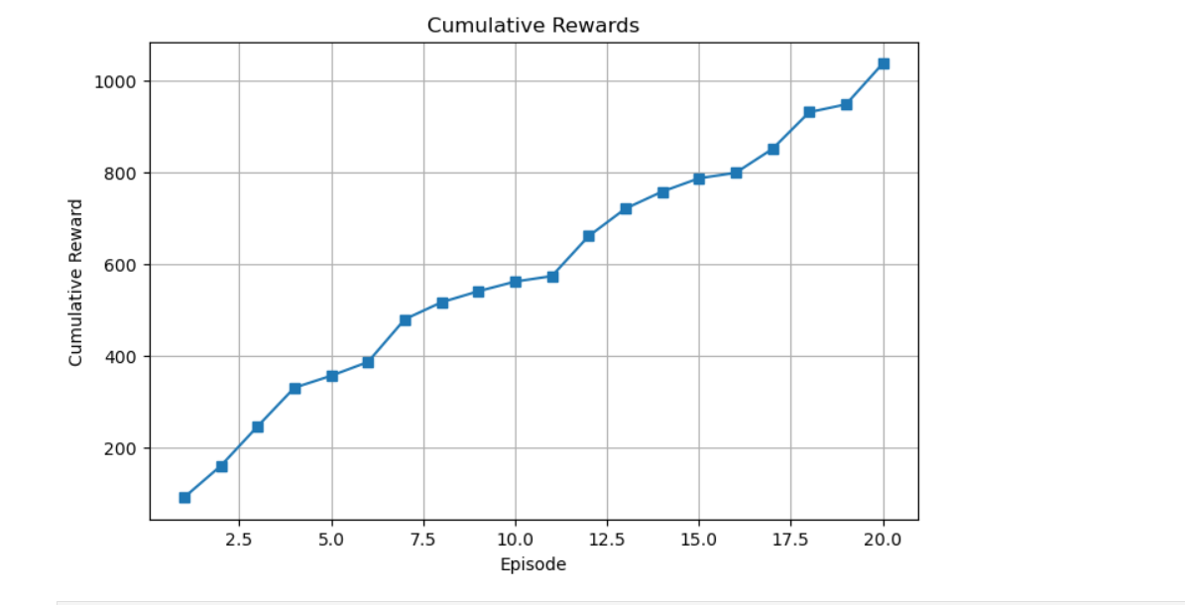
Experiment 9: TensorFlow and Keras-Based Neural Network for RL
Aim: To build a simple feed-forward neural network using TensorFlow and Keras for
approximating value functions in Reinforcement Learning environments.
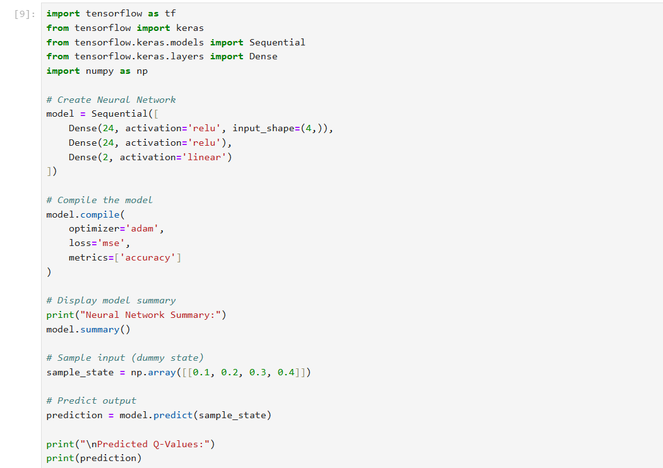
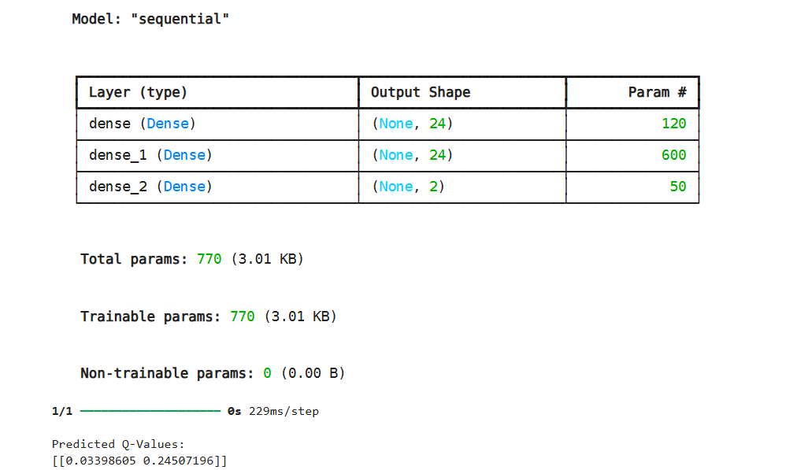Experiment 10: Mini Reinforcement Learning Project Using CartPole
Aim: To develop a basic Reinforcement Learning agent using TensorFlow and Keras
to solve the CartPole environment and evaluate its learning performance through
episode rewards and success rate.
